

Bachelor´s degree in Telecommunications Technologies Engineering (2017-2018)

Bachelor Thesis

“Python Module Development for Machine Learning Evaluation”

Jaime de los Ríos Mouvet

Tutor: Francisco J. Valverde Albacete

Co-Tutor: Carmen Peláez Moreno

(Leganés, Madrid, September 2018)

   
*[Include this code in case you want your Bachelor Thesis published in Open Access University Repository]*

This work is licensed under Creative Commons Attribution – Non Commercial – Non Derivatives

ABSTRACT

This paper focuses on the study and creation of a software library in the programming language "Python" where a series of information-theoretic tools described by Valverde-Albacete and Peláez Moreno are implemented. [Pattern Recognition Letters 31.12 (2010) and PLoS ONE 9.1 (2014)]. The bases and concepts defined in the cited article, provide us the necessary skills to be able to evaluate the effectiveness of techniques and methods used in the generation of machine learning models. Therefore, this document will introduce a visual interpretation of the performance within a multi-class classification scheme. These functionalities will be contained into a Python package, that can be distributed to the whole community.

The library created will provide users the ability of plotting diagrams known as Entropy Triangles which are a kind of De Finetti diagrams. It is used as an exploratory analysis method for calculating the balance equation of entropies for the estimated distributions of the input and the output of classifiers. In this particular case, Entropy calculations can be made in two different situations that will be seen more in depth. To sum up, this tool will provide the ability to Python users of measuring and evaluating the performance of their multi-class classifications tasks in a visual way never used before, as well as evaluating the quality of the databases used in the classification techniques.

Python is a powerful object-oriented open-source scripting language created in the late 80's by Guido van Rossum in the Netherlands, has a syntax that encourages readable code, is multiplatform and being an open source language, benefits users for having a larger amount of resources and code available, in this case, for data processing and the application of machine learning techniques. Therefore, it is expected that the development of the library will provide a functionality that has not been yet available in the community.

In this document we describe the design and development of the software package. Before that, we set the theoretical backdrop reviewing the implemented tools and their mathematical background. To illustrate the software features and the utility of the tools, we present an example with a multi-class dataset in which we unbalance the class distribution in different ways. Additionally, we introduce how to use the plug-in programmatically with a guided example. Finally, we review the project in hindsight and propose future work.

**Keywords:** Machine Learning, Information Entropy, Classification algorithms, Information-Theory, Entropy triangles

ACKNOWLEDGEMENTS

My gratitude goes out to the people who have supported me along the road, not only during the preparation of this project, but throughout my entire career, particularly to my parents and family, to whom I will always be grateful. Finally, I would like to thank the teachers who have accompanied me during the development, as I have learned so much in a subject that I especially enjoy and to which I hope to devote myself in the future.

INDEX

ABSTRACT 3

1. INTRODUCTION 7

1.1 Motivation 7

1.2 Objective 8

1.3 Outline 8

2. BACKGROUND 9

2.1 Entropy and mutual information 9

2.1.1 Entropy 9

2.1.2 Joint entropy and Conditional entropy of two variables 9

2.1.3 Properties of the entropic quantities [] 10

3. SOFTWARE DEVELOPED 32

# INTRODUCTION

This report presents a complete Python Package for the performance evaluation of machine learning tasks such as data transformation, multi-class classifiers and database characterization based on information-theoretic tools. It is based in a series of papers [] and similar tools for Matlab, Weka and R.

## Motivation

Technology has helped industries to have a descriptive and analytical perspective of the company´s activities they carry out based on data to analyze situations and choose strategies. However, since the use of systems that use machine learning, perspective has advanced and adopted a more predictive trend. So instead of using technology, for example, to analyze and describe customer needs, technology is based now on detecting data patterns and predicting customer needs based on their characteristics.

For that reason, a sort of different algorithms was developed for deploy this pattern recognition tasks. In particular, one of the most used techniques is supervised classification, which are algorithms that use a set of classified examples (training data) to assign a classification to a second set of examples (test data).

Although this is one of the most widely used techniques, and its use is widespread, we are faced with a shortage of technical tools that allow us to check how these machine models perform. For that reason, Valverde-Albacete and Peláez-Moreno initially developed a series of information-theory tools that precisely solve this problem and let us evaluate the performance of multiclass classification (ref).

Furthermore, the tools mentioned dealt as the basis for a posterior generalization made for the description of a new set of information-theory metrics for other different machine learning tasks like evaluating some data feature transformation [], or the assessment of information within a database used in a machine learning duty(ref).

The definition of the theoretical concepts was followed by the creation of software in platforms such as Matlab, Weka or R. However, there was no software implemented for one of the most used programming languages nowadays which is Python. In addition, it can be pointed out that Python is one of the most used language when talking about scientific computing, and in special, for Data Science.

For that reason, the aim of this project is the creation of a tool for the evaluation of machine learning methods, by means of tools from information theory, with the goal of providing a distributable package in Python, for extending these concepts and functionalities to researchers but also for daily community users.

## Objective

Objetivo concreto de este estudio (Antecedentes, estado de la cuestión, supuesto o hipótesis de trabajo)

https://medium.com/@UdacityINDIA/why-use-python-for-machine-learning-e4b0b4457a77

## Outline

The paper is going to introduce and present all the concepts necessary to understand the code presented to meet the objectives mentioned above, therefore, it will be structured in 3 parts. A first theoretical section (Section 2) where all the theory behind the tools used are reviewed, from the information measures needed for the calculation, to the software used for the code creation.

In the Section 3, the (DESARROLLO DEL CÓDIGO)

Continuing, in the 4th section, (RESULTS)

Finally, in the last section (CONCLUSIONS)

# THEORETICAL BACKGROUND

Our code development is going to be based on the theories and the tools provided introduced in [all the papers here]. For that reason, this section will be based on the reviewing and the explanation of the mathematical background for providing a reference within the document.

## Entropy Measures

Information-theoretic measures can be used to provide tools for analyzing the flow of information in a transmission from some discrete multivariate source $\overline{X}$ to a discrete multivariate sink of information $\overline{Y}$ joined by a distribution $P_{ \overline{XY}}$. From papers [] we will use the defined *balance equations* whose normalization can be represented in a ternary plot or *de Finetti* diagram. These balance equations will represent the decomposition of the joint entropy of two random variables for the analysis of the information flow.

During the theoretical analysis, we can split two scenarios while talking from a data flow, one where the information transmission is made by single random variables $n= \left|\overline{X}\right|=\left|\overline{Y}\right|=p =1$ called *single-input single-output* (SISO) which is described by the joint distribution $P_{XY}$ and a second one where the transfer is stablished between random vectors, named as *multiple inputs and multiple outputs* (MIMO) which is defined by the joint distribution ($\overline{X} , \overline{Y}$) ~ $P_{\overline{XY}}$.

In this section, concepts needed for the definition of the balance equations in both scenarios are going to be defined, as well as the information theoretic measures used to define the equations and the posterior ternary diagrams known as Entropy Triangles.

#### Random Variables Entropic measures

Let $X$ and $Y$ be two random variables with some joint distribution $P_{XY }$, then for conceptualizing the transfer of information between the variables mentioned, some information quantities can be defined from a better understanding of the final entropy equations proposed in [].

##### Entropies of random variables

The *entropy* is a measure of information, which reflects the expected uncertainty of the outcome or the amount of information learnt on average from one instance of a random variable. From a random variable $X$ with a probability mass function [nota a pie de página] , the entropy is calculated as

$$H(X)=E\left[\log{\frac{1}{P_{X}}}\right]= -\sum_{i}{p\left(x_{i}\right)\log{(p\left(x_{i}\right))}}$$

Notice that the entropy only depends on the probability distribution of the variable $p\left(x\right).$

Now consider two random variables $X$ and $Y$, jointly distributed according to the p.m.f $p\left(x,y\right)$. We can now define some measures as the following:

* The *joint entropy* of two variables, will measures how much uncertainty are in the two random variables X and Y taken together. []
$$H(X,Y)=E\left[\log{\frac{1}{p(x,y)}}\right]= -\sum_{x,y}{p\left(x,y\right)\log{(p\left(x,y\right))}}$$

* Secondly, we can define the *conditional entropy* of $X$ given $Y$ which measures the uncertainty remaining of r.v. $X$ when known the value of the of $Y$ [].

$$H(X|Y)=E\left[\log{\frac{1}{p(x|y)}}\right]= -\sum_{x,y}{p\left(x,y\right)\log{(p\left(x|y\right))}}$$

This relations of the two random variables will be essential for the posterior entropic analysis, as will help us for instance to calculate in our case, the amount of information shared by 2 variables, or the variation of information between them.

###### Entropy Properties:

We can define several properties of the entropic measures seen.

* *Non-Negativity* []: $H\left(X\right) ≥0$, entropy is always non-negative. If $H\left(X\right)=0$, then $X$ is deterministic
* *Chain rule* []: We can decompose the joint entropy as follows:

$H(X_{1}, X_{2}, …, X_{n})= \sum_{i=1}^{n}{H\left(X_{i} | X_{i}^{c}\right)}$

where $(where X_{i}^{c}= X \backslash \left\{X_{i}\right\})$. For two variables then the chain rule can will be

$$H\left(X,Y\right)= H\left(X | Y\right)+H\left(Y\right)= H\left(Y | X\right)+H\left(X\right)$$

Noticing that in general $H\left(X | Y\right) ≠ H\left(Y | X\right)$

* *Monotonicity* []: Conditioning always reduces entropy:
$$H\left(X|Y\right)≤H(X)$$

* *Maximum entropy* []: The maximum value is achieved when the random variable $X$ is uniformly distributed, and that value will be

$$H\left(X|Y\right) ≤\log{(k)}$$

Being $k$ the number of values that the discrete random variable $X$ could take.

* *Independent variables*: When $X$ and $Y$ are independents variables, then

$$H\left(X,Y\right)=H\left(X\right)+H(Y)$$

$$H\left(X|Y\right)=H\left(Y\right) H\left(Y|X\right)=H(X)$$

Once we understand the basic measures of entropies that can be measured when talking about random variables, we are going into the decomposition of the joint entropy of two random variables, defining some regions from []. For instance, we can define from [] the mutual information of two variables or the variation of information between the both variables as in [].

##### Mutual information

The *mutual information* of two variables measures the amount of information that the variables share [ref to Shannon’s original papers]. This is the information, or uncertainty, that remains when subtracting from one variable the uncertainty of the same variable given the other

$${MI}_{XY}= H_{X}- H_{X|Y}= H_{Y}- H_{Y|X}$$

Notice that two independent variables do not share mutual information (${MI}_{XY}=0$) as $H_{X|Y}=H_{X}$

##### Variation of information

The *variation of information* is the opposite concept to the mutual information as it is interpreted as the distance between 2 random variables[ref to Meila]. So, the variation of information can be calculated extracting the mutual information present in each variable. It is also called the residual information

$${VI}_{XY}= H_{X}+ H_{Y}-2·{MI}_{XY}$$

##### Binary Entropy Triangle

The transfer of information from single input to single output is going to be measured using the well-known measures dating back to Shannon [ref] but considering an extended relation between them in the form of a balance equation for their joint entropy based in []. So, using the previous concepts defined in the previous section let´s depict the disengaging of the joint entropy of two random variables shown on the i-diagram of figure () as the 3 main regions represented:

* *Divergence with respect uniformity ${∆H}_{P_{X}·P_{Y}}$* , between the joint distribution where $P_{X}$ and $P_{Y}$ are independent and the uniform distributions with the same cardinality of events as $P_{X}$ and $P_{Y}$.

$${∆H}_{P_{X}·P_{Y}} = H_{U_{X}·U_{Y}}- H_{P_{X}·P_{Y}}$$

$$H_{P_{X}·P_{Y}} ≤ H_{U_{X}·U_{Y}}$$

It shows how imbalanced the data are and the results of the transformation are, represented in Figure () as the bordered yellow area []

* *Mutual Information, ${MI}_{P_{XY}}$* as the force of the stochastic binding between $P_{X}$ and $P_{Y}$, “towards the outside”. It can be also considered the decrease in entropy when passing form distribution $Q_{XY}=P_{X}·P_{Y}$ to $P_{XY}$ (outside area) [3,]

$${MI}_{P_{XY}}= H_{P_{X}·P_{Y}}- H_{P_{XY}}$$

but it also might be considered “towards the inside” []

$${MI}_{P_{XY}}= H_{P_{X}}- H_{P_{X|Y}}= H_{P_{Y}}- H_{P_{Y|X}}$$

Represented in the i-diagram of the figure () by the green area and can be separated in 2 parts.

* *Variation of information* [15] ${VI}_{P_{XY}}$ that embodies the residual entropy, not used in the binding of the variables.

$${VI}_{P_{XY}}= H_{P_{X|Y}}- H_{P_{Y|X}}$$

In Figure () the variation of information is represented by the red area (sum of the conditional entropies)

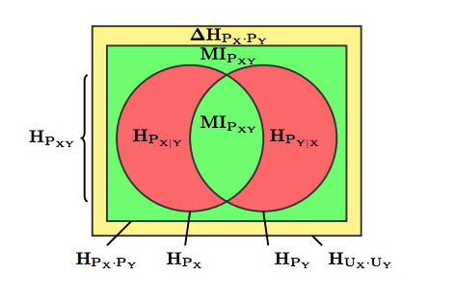

Fig. (reprinted from ())

Balance Equation

After defining these concepts that helps us to decompose the information measures for the joint distribution, we can now write the *entropy balance equation* defined in [1] of two discrete random variables $X$ and $Y$ that can be derived from figure ():

$$H_{U_{X}·U_{Y}} ={∆H}_{P_{X}·P_{Y}}+2* {MI}_{P_{XY}}+ {VI}_{P_{XY}}$$

$$0 ≤ {∆H}_{P_{X}·P_{Y}} , 2* {MI}_{P_{XY}} , {VI}_{P_{XY} }≤ H_{U_{X}·U_{Y}}$$

Split Balance Equations

The logarithmic nature of the entropy gives the possibility of decomposing the balance equation of a joint distribution for analyzing the behavior of each variable distribution as shown in the modified i-diagram in figure (). For instance, we can split some joint entropy measurement into an individual values addition ($H_{U_{X}·U_{Y}}=H_{U_{X}}+H_{U_{Y}}$). For that reason, we can expand the formula () to

$${∆H}_{P_{X}·P_{Y}}=H_{U_{X}·U_{Y}}- H_{P_{X}·P_{Y}}=\left(H_{U_{X}}- H_{P_{X}}\right)+\left(H_{U_{Y}}- H_{P_{Y}}\right)= {∆H}_{P_{X}}+ {∆H}_{P_{Y}}$$

Extending it to the balance equation () will generate the splitted version

$$H_{U_{X}} ={∆H}_{P_{X}}+ {MI}_{P_{XY}}+ H_{P_{X|Y}} H_{U_{Y}} ={∆H}_{P_{Y}}+ {MI}_{P_{XY}}+ H_{P_{Y|X}}$$

$$0 ≤ {∆H}_{P_{X}·} , {MI}_{P_{XY}} , H_{P_{X|Y}}≤ H_{U_{X}} 0 ≤ {∆H}_{P_{Y}} , {MI}_{P_{XY}} , H_{P_{Y|X}}≤ H_{U_{Y}}$$

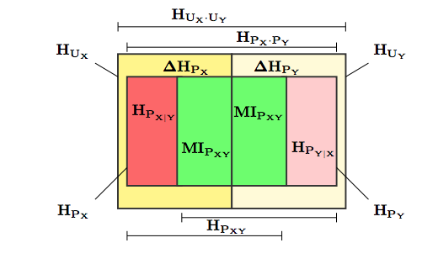

Fig. reprinted from ()

Channel Binary Entropy Triangle

The entropy triangle is a representation of the balance equations on the *de Finetti* diagram. Considered as a ternary chart, is a barycentric diagram used to represent 3 variables that combined, sum a given constant value. The variables of the ternary diagram always will sum a constant value $a+b+c =k$ ($k>0$) therefore, the existence of a relationship of dependence between two variables and the third variable can be noted, for instance, $a= k-(b+c)$. []

Then, for computing the entropy triangle, some normalization in $H_{U_{X}·U_{Y}}$ is going to be applied in the equation ()

$$1 ={∆H'}_{P_{X}·P_{Y}}+2* {MI'}_{P_{XY}}+ {VI'}_{P_{XY}}$$

$$0 ≤ {∆H'}_{P_{X}·P_{Y}} , 2* {MI'}_{P_{XY}} , {VI'}_{P_{XY} }≤ 1$$

Which represents the 2-simplex in normalized ${∆H'}_{P_{X}·P_{Y}} × 2* {MI^{'}}_{P_{XY}} × {VI^{'}}_{P_{XY} }$ space. At the end, each joint distribution $P_{XY}$ can be characterized by its joint entropy coordinates, or entropic composition (Aitchison, 1982; Pawlowsky-Glahn, Egozcue, & Tolosana-Delgado, 2015) $F\left(P_{XY}\right)=\left[{∆H'}_{P_{X}·P_{Y}} , 2* {MI'}_{P_{XY}} , {VI'}_{P_{XY}}\right]$ whose projection onto the $\left(1,1,1\right)$ direction vector is it´s de Finetti diagram. This particular case is called the *Channel Bivariate Entropy Triangle,* CBET and will be used for the evaluation of a multi-class classification task.

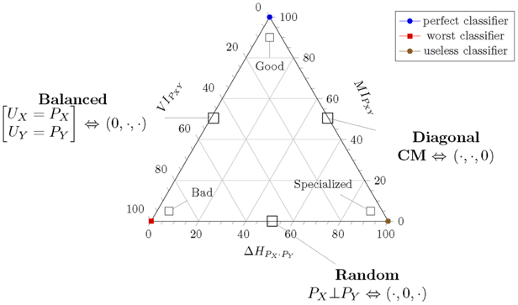

Figure ()

The representation of the balance equation on the diagram provides basically a graphical assessment of joint distribution in terms of information theory. We can review some borderline cases, defined by regions where one of the components of the balance equation (Eq) is equal to zero. With $X$ and $Y$ with joint distribution $P_{XY}$, then at the ET we can differ some characteristic regions

* Left Side (${∆H'}_{P_{X}·P_{Y}}=0$) This region represents variables that has a uniform joint distribution for its input and output variables.
* Right Side (${VI'}_{P_{XY}}=0$) portrays the regions in which there is not variation of information, meaning that all the information from a variable X to Y is shared or transferred while talking about a transmission.
* Bottom Side (${MI'}_{P_{XY}}=0$) depict the scenario when the mutual information between 2 variables X and Y is equals to 0, meaning that X and Y are independents variable that not share any information.

Figure () presents the Entropy triangle of the mentioned cases points in the case we evaluate the performance of classifiers, that fulfills the conditions in the vertices of the triangle.

Split Binary Entropy Triangle

The entropy triangle is going to represent the separated balance equations as well of each of the marginal distributions. We will just need to normalize the splitted equations by the corresponding value $H_{U_{X}}$ or $H_{U_{Y}}$

$$1 ={∆'H}_{P_{X}}+ {MI'}_{P_{XY}}+ {H'}_{P_{X|Y}} 1 ={∆'H}_{P_{Y}}+ {MI'}_{P_{XY}}+ {H'}_{P_{Y|X}}$$

$$0 ≤ {∆'H}_{P_{X}·} , {MI'}_{P_{XY}} , {H'}_{P_{X|Y}}≤ 1 0 ≤ {∆H}_{P_{Y}} , {MI}_{P_{XY}} , {H'}_{P_{Y|X}}≤ 1$$

Since these are also equations on a 2-simplex, we can actually represent the coordinates $F_{X}\left(P_{XY}\right)=\left[{∆H'}_{P_{X}} , {MI'}_{P_{XY}} , {H'}_{P_{X|Y}}\right]$ and $F_{Y}\left(P_{XY}\right)=\left[{∆H'}_{P_{Y}} , {MI'}_{P_{XY}} , {H'}_{P_{Y|X}}\right]$ in the same triangle side by side the original $F\left(P_{XY}\right)$, whereby the representation seems to split in two.

#### Random vectors Entropic measures

After defining the bivariate entropy balance equation, where the transmission of information occurs between the random variables $X$ and $Y$, the extension of the entropies decomposition characterizing a joint distribution $P_{XY}$ of a multivariate inputs and outputs (MIMO) is covered. For this reason, before reviewing different flavors of the information measures of multivariate sets for the development of a general entropy balance equation, lets differentiate between the 2 scenarios to face as mentioned in []

Scenario 1) All the random variables form part of the same set $\overline{X}$ and we are looking at information *content within* this set. (Source-MET Section 2.1.2.1)

Scenario 2) Random variables are portioned in two different sets $\overline{X}$ and $\overline{Y}$ and we are looking at information *transfer* *between* the sets. (Channel-MET Section 2.1.2.2)

##### Random Vectors as sources

We will try in this section to generalize the balance equations and entropy triangles to the case of multiple variables $\overline{X}$ taken as joint source of information with a multivariate distribution $\overline{X}\sim P_{\overline{X}}$. For the generalization, new information measures and concepts will be applied, hence, we will first introduce them from [].

* + - * 1. Entropy of a Multivariate Source

Paper [] reviews different flavors of information measures describing more than two variables. Since the *i-diagrams* are a powerful tool to visualize the interaction of distribution in the bivariate, we will try to extend them for sets of random variables. However, there may be some caveats for their multivariate use, for instance with the possibility of obtaining some negative “areas” when not considering signed measures of probabilities. Furthermore, when increasing the number of variables in the analysis, some new areas defined by () will appear and affect directly on the behavior of the joint entropy decomposition of the random vector. For that reason, we will define and establish some new entropies measures.

Multivariate Source Mutual Information

James et al. (2011) pointed out that some information measures stem from focusing in a particular property of the bivariate mutual information and generalize it to the multivariate setting, and the properties in question are:

${MI}_{P_{XY}} =H_{P_{X}}+ H_{P_{Y}}- H_{P_{XY}}$

${MI}_{P_{XY}} =H_{P_{X}}- H_{P_{X|Y}}$

${MI}_{P_{XY}}= \sum_{x,y}{P_{XY}\left(x,y\right)\log{\frac{P_{XY}(x,y)}{P_{X}(x)P_{Y}(y)}}}$

These properties do not translate inconditionally to the multivariate settting… (go on explaining).

As mentioned in [], we can consider the scenario where we are using a vector of random variables $\overline{X}$ ∼ $P_{\overline{X}}$, let $\prod_{\overline{X}}{=} \prod_{i=1}^{n}{P_{X_{i}}}$ be the (jointly) independent distribution with similar marginals to $P_{\overline{X}}$. We are going then to consider the figure () as the distribution i-diagram of $\overline{X}=[X_{1},X_{2},X_{3}]$ with $\prod_{\overline{X}}{=}P_{X_{1}}·P_{X_{2}}·P_{X_{3}}$ as the inner rectangle containing both green areas in figure (). Then the mutual information is decomposed in different properties:

* The *total correlation $C_{P_{\overline{X}}}$* [], *integration* [] or *multiinformation*, which is represented by the green area outside $H_{P_{\overline{X}}}$ in Figure ()
$$C_{P_{\overline{X}}} =H_{\prod_{\overline{X}}{e}}- H_{P_{\overline{X}}}$$

* The *Dual total correlation $D_{P_{\overline{X}}}$*  [] or *interaction complexity*, is a generalization of (4), represented by the green area inside $H_{P_{\overline{X}}}$ in Figure ()
$$D_{P_{\overline{X}}} =H_{P_{\overline{X}}}- {VI}_{P_{\overline{X}}}$$

* The *interaction information* [18,19] or *co-information generalization* of () the total amount of information to which all variables contribute. It is represented by the inner convex area (within the *dual total correlation*) but it can be negative for $n>2$ (Abdallah & Plumbley, 2010).
$${MI}_{P_{\overline{X}}}= \sum{P_{\overline{X}}\left(\overline{x}\right)\log{\frac{P_{\overline{X}}\left(\overline{x}\right)}{\prod_{\overline{X}}{(\overline{x})}}}}$$

* The *local exogenous information* [10] or the bound information [22] is the addition of the total correlation and the dual total correlation.

$$M_{P_{\overline{X}}} =C_{P_{\overline{X}}}+ D_{P_{\overline{X}}}$$

Once we depict the measures of the multivariate case, then, we will continue by analyzing the generalization of the entropy balance equations for this particular case.

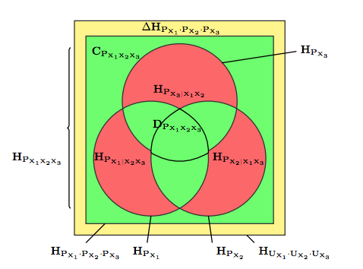

Fig (reprinted from ())

Random Vector variation of information

[] reviewed the measures of multivariate information and pointed out that measures involving amounts of entropy shared by variables, are not called *information,* for instance, we must consider that every random variable has a residual entropy, which is the information not explained by other variables.

This residual entropy [] $H_{P_{X_{i}|X_{i}^{c}}}-$ where $X_{i}^{c}= \overline{X} \backslash \left\{X_{i}\right\}-$ can be grouped in a measure call residual information or multivariate variation of information ${VI}_{P_{\overline{X}} }$ which is the generalization of the same quantity of the bivariate case, and it is calculated by adding all

the residual entropies of the data set.

* + - * 1. Source Entropy Triangle (SMET)

Once we have the tools necessaries for understanding the composition of either the mutual information of random vectors or the variation of information, then we can represent as in the previous sections the measures needed for defining the general multivariate entropic source balance equation as the following:

* Divergence with the uniform multivariate distribution ${∆H}_{\prod_{\overline{X}}{e}}$ [] represented by the outer yellow zone of the figure ().
$${∆H}_{\prod_{\overline{X}}{e}}= H_{U_{\overline{X}}}- H_{\prod_{\overline{X}}{e}}$$

$${∆H}_{\prod_{\overline{X}}{e}}= \sum_{i=1}^{n}{H_{U_{X_{i}}}}- \sum_{i=1}^{n}{H_{P_{X_{i}}}}= \sum_{i=1}^{n}{H_{U_{X_{i}}}- H_{P_{X_{i}}}}= \sum_{i=1}^{n}{{∆H}_{P_{X_{i}}}}$$

* *Mutual information or Bound information $M_{P_{\overline{X}}}$* shown in the figure () is represented by the sum of all the red zones at figure ().
$$M_{P_{\overline{X}}}= C_{P_{\overline{X}}}+ D_{P_{\overline{X}}} = H_{\prod_{\overline{X}}{e}}- H_{P_{\overline{X}}}+ H_{P_{\overline{X}}}- {VI}_{P_{\overline{X}}}= H_{\prod_{\overline{X}}{e}}- {VI}_{P_{\overline{X}}}$$

* *Multivariate variation of information* [] ${VI}_{P_{\overline{X}}}$ shown in the figure () is represented by the sum of all the red zones (repeated from equation ____) figure ().

$${VI}_{P_{\overline{X}}}= \sum_{i=1}^{n}{H_{P_{X_{i}|X_{i}^{c}}}}$$

These are the necessary measures needed for extending the balance equation for a bivariate case into the multivariate one. Paper [] presents some theorems to introduce and derive the aggregate and the split entropy balance equation for a multivariate source of data.

Balance Equations

*Theorem 1*. (Aggregate source multivariate balance equation). Let $P_{\overline{X}}$ be an arbitrary discrete distribution over the set of random variables $\overline{X}$. Then, the following balance equation holds

$$H_{U_{\overline{X}}}= {∆H}_{\prod_{\overline{X}}{e}}+ M_{P_{\overline{X}}}+ {VI}_{P_{\overline{X}}}$$

$$0 ≤ {∆H}_{\prod_{\overline{X}}{e}}, M_{P_{\overline{X}}} , {VI}_{P_{\overline{X}}} ≤ H_{U_{\overline{X}}}$$

This equation will be the generalization for the multivariate source case of the entropy balance equation.

Multi-Split Balance Equations

From the general equations, we're going to try to get the multi-split balance equations for evaluating independently the information measures of each variable. To do so, we are going to rely on the second theorem presented in paper [] which reads as follows

*Theorem 2* (Multi spit source multivariate balance equation)

Let $P_{\overline{X}}$ be an arbitrary discrete distribution over the set of random variables $\overline{X}= {\{X_{i}\}}_{i=1}^{n}$, then, with the definitions above, the balance equation holds for each variable individually:

$$H_{U_{X_{i}}}= {∆H}_{P_{X_{i}}}+ M_{P_{X_{i}}}+ H_{P_{X_{i}|X_{i}^{c}}} 1≤i ≤n$$

$$0 ≤ {∆H}_{P_{X_{i}}} , M_{P_{X_{i}}} , H_{P_{X_{i}|X_{i}^{c}}} ≤ H_{U_{X_{i}}} 1≤ i ≤n$$

With both equations, the aggregated and the splitted now we can define the source entropy triangle for the multivariate case.

Source Entropy Triangle

A generalization from the balance equations and entropy triangles defined in section () to are made to the case of multiple variables $\overline{X}$ taken as a joint source of information. So, as it´s reported and derived in paper [] we now may normalize the aggregate source multivariate balance equation by $H_{U_{\overline{X}}}$

$$1= {∆H'}_{\prod_{\overline{X}}{e}}+ {M'}_{P_{\overline{X}}}+ {VI'}_{P_{\overline{X}}}$$

$$0 ≤ {∆'H}_{\prod_{\overline{X}}{e}}, {M'}_{P_{\overline{X}}} , {VI'}_{P_{\overline{X}}} ≤ 1$$

Then, from [] we can define the composition $F\left(P_{\overline{X}}\right)=\left[{∆'H}_{\prod_{\overline{X}}{e}}, {M'}_{P_{\overline{X}}} , {VI'}_{P_{\overline{X}}}\right]$ for the representation of the ternary diagram on the aggregate entropy. As in the channel case, we can now define some regions of the multivariate source representation []:

• If $P_{\overline{X}}= \prod_{\overline{X}}{=} \prod_{i=1}^{n}{P_{X_{i}}}$, then $F\left(P_{\overline{X}}\right)=\left[· , 0 , ·\right]$ is the location of distributions with independent marginals.

• If $P_{X_{i}}= U_{X_{i}} , 1≤i ≤n$ then $F\left(P_{\overline{X}}\right)=\left[0, · , ·\right]$ is the geometric location of distribution with uniform marginals. ${∆H}_{P_{X_{i}}}=0$

• If $P_{X_{i}}= P_{X_{j}} , i ≠j$ then $F\left(P_{\overline{X}}\right)=\left[· , · , 0\right]$ is the locus of distribution with identical marginals and in general high bound information

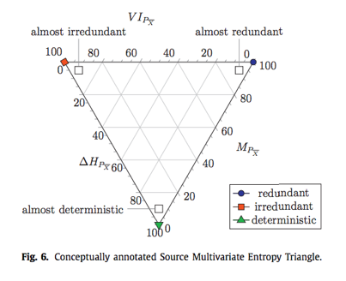

Figure ()

In this case, the interpretations of the variables of the SMET are different as they were in the channel triangle. The multivariate residual entropy ${VI}_{P_{\overline{X}}}$ is the sum of amounts of information singularly captured by each variable, then the total bound information $M_{P_{\overline{X}}}$ can be analyzed as the redundancy in every portion residing in (at least) two different variables. Finally, the divergence from uniformity is the maximal randomness of the source of information that has not been realized and it´s not available for latter processing.

Figure () represents the SMET, that seems a representation of the channel case, but rotated. That happens because of the divergence from uniformity is a deleterious quantity of information, that’s why is represented as a down-growing quantity by rotating the triangle. It also shown the coordinates represented the boundary cases that represent the areas that will characterize the data sources analyzed.

Multi-Split Entropy Triangle

When plotting the aggregate visualization of a joint distribution of a sink of information $\overline{X}$, we are representing an average of the component decomposition for different variables () - (). However, we can disaggregate the visualization like in the previous section for a better unique variable analysis.

From () we can normalize the equation for the split balance but on each of the individuals $H_{U_{X_{i}}}$ for obtaining:

$$1= {∆H'}_{P_{X_{i}}}+ {M'}_{P_{X_{i}}}+ {H'}_{P_{X_{i}|X_{i}^{c}}} 1≤i ≤n$$

$$0 ≤ {∆H'}_{P_{X_{i}}} , {M'}_{P_{X_{i}}} , {H'}_{P_{X_{i}|X_{i}^{c}}} ≤ 1$$

Then for each multivariate $\overline{X}= {\{X_{i}\}}_{i=1}^{n}$ we can write for each marginal $P_{X_{i}}$, the coordinates in a de Finetti diagram as $F\left(P_{X_{i}}\right)=\left[{∆H'}_{P_{X_{i}}} , {M'}_{P_{X_{i}}} , {H'}_{P_{X_{i}|X_{i}^{c}}}\right]$. They will be represented in the same entropy triangle as the multisplit Source Multivariate Entropy Triangle.

##### Random vectors as a Joint distribution (Channel)

The characterization of the joint distribution $P_{\overline{XY}}$ between random vectors $\overline{X}$ and $\overline{Y}$ will be analogous to the bivariate case but considering multivariate input and output. So, considering the i-diagram in figure () we can visualize the updated diagram from figure () differentiating two random vectors $\overline{X}$ and $\overline{Y}$ with a joint distribution $P_{\overline{XY}}$.

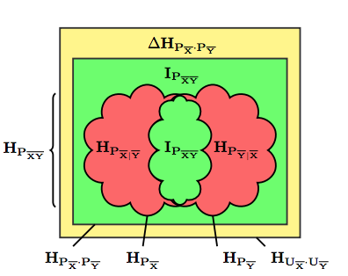

Fig. (reprinted from ())

From this point we can stablish proper generalizations of the entropic measures defined in the bivariate case but now using random vectors as some distributions around $P_{\overline{XY}}$ are highlighted in the i-diagram of the figure (). As mentioned in [] if we focus on the distinction between 2 random vectors $\overline{X}$ and $\overline{Y}$, a proper multivariate generalization of the *variation of information* in Equation () is

$${VI}_{P_{\overline{XY}}}= H_{P_{\overline{X}|\overline{Y}} }- H_{P_{\overline{Y}|\overline{X}} }$$

Which represents the addition of information in $\overline{X}$ not shared with $\overline{Y}$ and vice-versa, and besides it is a positive value as is a sum of entropies, it is captured in the figure () as the red area.

Next, we can consider $U_{\overline{XY}}$, the uniform distribution over the supports of $\overline{X}$ and $\overline{Y}$, and $P_{\overline{X}} × P_{\overline{Y}}$, the distribution created with the marginals of $P_{\overline{XY}}$ considered independent. Thus, we can define the multivariate divergence with respect uniformity as a analogy of Equation ()

$${∆H}_{P_{\overline{X}} × P_{\overline{Y}}} = H_{U_{\overline{XY}}}- H_{P_{\overline{X}} × P_{\overline{Y}}}$$

This can be represented as the yellow area in figure (). In addition, we can conclude from [] that the multivariate divergence with respect to uniformity admits splitting as

$${∆H}_{P_{\overline{X}} × P_{\overline{Y}}} = {∆H}_{P_{\overline{X}}}+ {∆H}_{P_{\overline{Y}}}$$

Because $H_{U_{\overline{XY}}} = H_{U_{\overline{X}}}+ H_{U_{\overline{Y}}}$ and $H_{P_{\overline{X}} × P_{\overline{Y}}} = H_{P_{\overline{X}}}+ H_{P_{\overline{Y}}}$

These generalizations are straightforward and intuitively agree with the intuitions provided by the CBET.

* + - * 1. Mutual information in a MV

Although the above concepts have been defined through a generalization of the bivariate case, we now deal with the problem of defining the mutual information between 2 random vectors. For that reason, we can define from [] a “remanent information” represented by the inner area in the i-diagram of figure ()

$$I_{P_{\overline{XY}}}=H_{P_{\overline{XY}}}-{VI}_{P_{\overline{XY}} }$$

As mentioned in [] this can be easily “refocused” on each of the subsets of the partition:

***Lemma 1***: Let $P_{\overline{XY}}$ be a discrete joint distribution. Then

$$H_{P_{\overline{X}}}- H_{P_{\overline{X}|\overline{Y}} }=H_{P_{\overline{Y}}}- H_{P_{\overline{Y}|\overline{X}} }= I_{P_{\overline{XY}} }$$

*Proof.* Recalling that the conditional entropies are easily related to the joint entropy by the chain rule $H_{P_{\overline{XY}} }= H_{P_{\overline{X}}} + H_{P_{\overline{Y}|\overline{X}}}= H_{P_{\overline{Y}}}+ H_{P_{\overline{X}|\overline{Y}}}$, simply subtract ${VI}_{P_{\overline{XY}}}$

***Lemma 2:*** Let $P_{\overline{XY}}$ be a discrete joint distribution. Then

$$I_{P_{\overline{XY}}}= H_{P_{\overline{X}} × P_{\overline{Y}} }- H_{P_{\overline{XY}} }$$

*Proof.* Considering the entropy decomposition of $P_{\overline{X}} × P_{\overline{Y}}$

$$H_{P_{\overline{X}} × P_{\overline{Y}} }- H_{P_{\overline{XY}}}= H_{P_{\overline{X}}}+ H_{P_{\overline{Y}}}-\left(H_{P_{\overline{Y}}}+ H_{P_{\overline{X}|\overline{Y}}}\right)= H_{P_{\overline{X}}}- H_{P_{\overline{X}|\overline{Y}}}= I_{P_{\overline{XY}}}$$

This is the quantity of information required to bind $P_{\overline{X}}$ and $P_{\overline{Y}}$, or in other words the amount of information lost from $P_{\overline{X}} × P_{\overline{Y}}$ to achieve a binding in $P_{\overline{XY}}$. It is represented by the outermost green area in figure ()

***Lemma 3:*** Let $P_{\overline{XY}}$ be a discrete joint distribution. Then

METER EQUACION TOCHA

*Multivariate mutual information* [] it can be represented as the inner green area in the figure () also known as “remanent information” or the quantity of information required to bind $P_{\overline{X}}$ and $P_{\overline{Y}}$ [] but also represented by the outer green area of the same figure, presenting the amount of information lost from to

* + - * 1. Channel Multivariate Entropy Triangle

Once introduced the measures needed to proceed with multivariate inputs and outputs, we will rely on theorems defined in [] for extracting the final aggregated multivariate entropy balance equation and whether if it is possible to split the equation as in the bivariate case.

Balance Equation

“Theorem 1. Let $P_{\overline{XY}}$ be a discrete joint distribution. Then the following decomposition holds:” $$H_{U_{\overline{X}} × U_{\overline{Y}} }={∆H}_{P_{\overline{X}} × P_{\overline{Y}}} +2* I_{P_{\overline{XY}}}+ {VI}_{P_{\overline{XY}}}$$

$$0 ≤ {∆H}_{P_{\overline{X}} × P_{\overline{Y}}} , 2* I_{P_{\overline{XY}}} , {VI}_{P_{\overline{XY}}}≤ H_{U_{\overline{X}} × U_{\overline{Y}} }$$

Proof. From () we have $H_{U_{\overline{X}} × U_{\overline{Y}} }={∆H}_{P_{\overline{X}} × P_{\overline{Y}}}+H_{P_{\overline{X}} × P_{\overline{Y}}}$ whence by introducing Equations () we obtained:

$$H_{U_{\overline{X}} × U_{\overline{Y}} }={∆H}_{P_{\overline{X}} × P_{\overline{Y}}} + I_{P_{\overline{XY}}}+ H_{P_{\overline{XY}}}= {∆H}_{P_{\overline{X}} × P_{\overline{Y}}} + I_{P_{\overline{XY}}}+ I_{P_{\overline{XY}}}+ {VI}_{P_{\overline{XY}}}$$

This theorem is followed by a series of conditions mentioned for the equation () which will fix the lower bounds on the entropy triangle [].

1. $\overline{X}$ marginal uniformity when $H_{P_{\overline{X}}}= H_{U_{\overline{X}}}$, $\overline{Y}$ marginal uniformity when $H_{P_{\overline{Y}}}= H_{U_{\overline{Y}}}$ and *marginal uniformity* when both conditions cooccur.
2. Marginal independence, when $P_{\overline{XY}}= P_{\overline{X}} × P_{\overline{Y}}$
3. $\overline{Y}$ determines $\overline{X}$ when $H_{P_{\overline{X}|\overline{Y}} }=0$, $\overline{X}$ determines $\overline{Y}$ when $H_{P_{\overline{Y}|\overline{X}} }=0$ and mutual determination, when $H_{P_{\overline{X}|\overline{Y}} }= H_{P_{\overline{Y}|\overline{X}} }=0$

Note that the conditions mentioned above are independent of each other and in the other hand, they conditionate the values of the other variables in the balance equations.

Split Channel Multivariate Balance Equation

As we did in previous sections the Eq () can be decomposed in separed equations. Following the previous theorem (Theorem 1) in the paper [] we can find other theorem to concrete whether the balance equation for multivariate random vectors also admits splitting.

*Theorem 2*. Let $P_{\overline{XY}}$ be a discrete joint distribution. Then the Channel Multivariate Entropy Balance equation can be split as:”

$$H_{U_{\overline{X}}} ={∆H}_{P_{\overline{X}}}+ I_{P_{\overline{XY}}}+ H_{P_{\overline{X}|\overline{Y}} } 0 ≤ {∆H}_{P_{\overline{X}}} , I_{P_{\overline{XY}}} , H_{P_{\overline{X}|\overline{Y}} }≤ H_{U_{\overline{X}} }$$

$$H_{U_{\overline{Y}}} ={∆H}_{P_{\overline{Y}}}+ I_{P_{\overline{XY}}}+ H_{P_{\overline{Y}|\overline{X}} } 0 ≤ {∆H}_{P_{\overline{Y}}} , I_{P_{\overline{XY}}} , H_{P_{\overline{Y}|\overline{X}} }≤ H_{U_{\overline{Y}} }$$

This can be proved in a similar way we did in Eq (). These quantities will be *non-negative.*

Channel Multivariate Entropy Triangle

The generalized formula for representing the information balance of a multivariate transformation is needed and presented in the equation __ []. Consequently, after the normalization of () the representation of the triangle will be

$$1={∆H'}_{P_{\overline{X}} × P_{\overline{Y}}} +2* {I'}_{P_{\overline{XY}}}+ {VI'}_{P_{\overline{XY}}}$$

$$0 ≤ {∆H'}_{P_{\overline{X}} × P_{\overline{Y}}} , 2* {I'}_{P_{\overline{XY}}} , {VI'}_{P_{\overline{XY}}}≤ 1$$

So definitely, this is the general *de Finetti* equation of the aggregated channel Multivariate Entropy Triangle, whose proportions for a joint distribution are:

$F\left(P_{XY}\right)=\left[{∆H'}_{P_{\overline{X}} × P_{\overline{Y}}} , 2* {I'}_{P_{\overline{XY}}} , {VI'}_{P_{\overline{XY}}}\right]$.

The tool basically is a graphical assessment of multivariate joint distribution. The figure () shows the portrayal of this entropy triangle, and the representation of the theorem __ limits conditions mentioned in [].

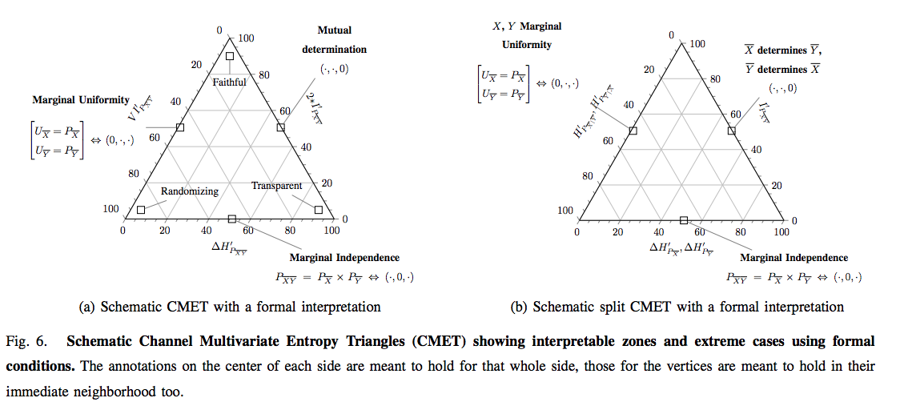

For the bounds determination we will list the bounding cases: []

* The lower side of the triangle with ${I'}_{P_{\overline{XY}}}= 0$, are affected by the marginal independence of blocks $\overline{X}$ and $\overline{Y}$ meaning that $P_{\overline{XY}}= P_{\overline{X}} × P_{\overline{Y}}$ the joint distribution does not share information. [] Then $F\left(P_{\overline{XY}}\right)=\left[· , 0 , ·\right]$
* The right side of the triangle with ${VI'}_{P_{\overline{XY}}}=0$, described with mutual determination $H_{P_{\overline{X}|\overline{Y}} }= H_{P_{\overline{Y}|\overline{X}} }$ = 0 , is the locus of partitioned joint distributions whose groups do not carry supplementary information to that provided by the other group[]. Being $F\left(P_{\overline{XY}}\right)=\left[· , · , 0\right]$
* The left side with ${∆H'}_{P_{\overline{X}} × P_{\overline{Y}}}=0$, describing distributions with uniform marginals $U_{\overline{X}}= P_{\overline{X}}$ and $U_{\overline{Y}}= P_{\overline{Y}}$, is the locus of partitioned joint distributions that offer as much potential information for transformations as possible $F\left(P_{\overline{XY}}\right)=\left[0, · , ·\right]$ []

Some descriptions can be obtained from the preceding conclusions mentioned, evaluating the areas that correspond to the vertices of the triangle.

OJO AQUI MEJOR EN REGIONES DE UN CLASIFICADOR

First, if we want a transformation from $\overline{X}$ to $\overline{Y}$ to be faithful, then we want to maximize the information used for mutual determination ${I'}_{P_{\overline{XY}}} →1$, equivalently, minimizing the divergence from uniformity ${∆H'}_{P_{\overline{X}} x P_{\overline{Y}}} →0$ and the information that only pertains to each of the blocks in the partition ${VI'}_{P_{\overline{XY}}} →0$. Then

However, if the coordinates of a distribution lay close to the left vertex ${VI'}_{P_{\overline{XY}}} →1$, then it shows marginal uniformity ${∆H'}_{P_{\overline{X}} × P_{\overline{Y}}} →0$ but shares little or no information between the blocks ${I'}_{P_{\overline{XY}}} →0$, hence it must be a randomizing transformation.

Finally, the distributions whose coordinates lay close to the right vertex ${∆H'}_{P_{\overline{X}} x P_{\overline{Y}}} →1$ are essentially deterministic and in that sense carry no information ${I'}_{P_{\overline{XY}}} →0$, ${VI'}_{P_{\overline{XY}}} →0$. Indeed, in this instance there does not seem to exist a transformation, whence we call them rigid.

Split Channel Entropy Triangle

The purpose of the representation of the split balance equations in the same diagram, is to evaluate the formal conditions separately of each block of data $\overline{X}$ and $\overline{Y}$. Then, with the independently normalization of equations () and () we will obtain the 2-simplex equations normalizing by $H_{U_{\overline{X}}}$ and $H_{U_{\overline{Y}}}$.

$$1 ={∆'H}_{P_{\overline{X}}}+ {I'}_{P_{\overline{XY}}}+ {H'}_{P_{\overline{X}|\overline{Y}} } 0 ≤ {∆'H}_{P_{\overline{X}}} , {I'}_{P_{\overline{XY}}} , {H'}_{P_{\overline{X}|\overline{Y}} }≤ 1$$

$$1 ={∆'H}_{P_{\overline{Y}}}+ {I'}_{P_{\overline{XY}}}+ {H'}_{P_{\overline{Y}|\overline{X}} } 0 ≤ {∆'H}_{P_{\overline{Y}}} , {I'}_{P_{\overline{XY}}} , {H'}_{P_{\overline{Y}|\overline{X}} }≤ 1$$

Note that we will overlap 2 different diagrams on the same triangle calling this representation as the *split Channel Multivariate Entropy Triangle* as represented in the figure ()*.* As shown in [] using the Theorem 1 mentioned, on the aggregated CMET but considering only one block at a time, for instance the block $\overline{X}$ (The $\overline{Y}$ case is the same scenario): []

• The lower side of the triangle with ${I^{'}}_{P_{\overline{XY}}}= 0$, is interpreted as before in the aggregated case (marginal independence). Then $F\left(P_{\overline{X}}\right)=\left[· , 0 , ·\right]$

• The right side is the location of the partitioned joint distribution whose $\overline{X}$ block is totally described by $\overline{Y}$ meaning $H_{P_{\overline{X}|\overline{Y}} }=0$ ($F\left(P_{\overline{X}}\right)=\left[· , · , 0\right])$

• The left side with ${∆H'}_{P_{\overline{X}} x }=0$, is the locus of partitioned distribution with uniform marginals $F\left(P_{\overline{X}}\right)=\left[0, · , ·\right]$

## The Information-Theoretic Approach to Evaluating Supervised Classification Tasks

Following the studies presented by (names) we have reviewed the theoretical basis and a set of tools for analyzing both the flow of information in a classification or information task. As mentioned in the articles, the use of information theory to assess classifiers is grounded on the analogy between a communication channel and a classification process [] since the input and output of a classifier can be related as a set of discrete random variables $\overline{X}$ and $\overline{Y}$ with a certain number of possible values $n$ ( $n$ being number of classes).

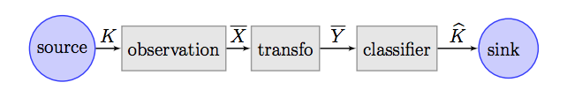

Figure ()

Based on the initial scheme of [], we will introduce the conceptualization of a supervised machine learning task of multi-classification, casted in an information theoretic setting as shown in figure (). First of all, there will be a set of *m* relations of a random vector $\overline{X}$ of features or observations variables paired with as many realizations of a class variable $K$. So, the set of values ${\left\{(k^{i},{\overline{x}}^{i})\right\}}_{1≤i≤m}$ will be called dataset.

The observations, then may be transformed in other instances of vector $\overline{Y}$ through a transformation function $f: \overline{X}→ \overline{Y}$ where ${\overline{x}}^{i}→ {\overline{y}}^{i}=f({\overline{x}}^{i})$ with the desired characteristics. For the supervised classification, the classifier is the subtask of inducing a function $k: \overline{Y}→ K, {\overline{y}}^{i}→ {\hat{k} }^{i}=k({\overline{y}}^{i})$ that tries to estimate $\hat{K}$.

In this context we will use the defined tools to assess the performance of the classification. We first can notice in the end-to-end panorama, that we can measure de effectiveness of the estimation of $\hat{K}$ from $K$, using the *Channel Binary Entropy Triangle.* Then, we will move to evaluate the features information contained on the database by the *Source Multivariate Entropy Triangle* use. Finally, we will measure the quality and the information transferred within the transformation block $f: \overline{X}→ \overline{Y}$ with the *Channel Multivariate Entropy Triangle*.

#### Communication Model

In a communication channel, let $\overline{X}=\left\{X_{i}\right| 1 ≤i ≤n\}$ be a set of discrete random variables with joint multivariate distribution $P_{\overline{X}}= P_{X_{1}…X_{n}}$, and the corresponding marginals $P_{X_{i}}\left(X_{i}\right)= \sum_{j ≠i}{P_{\overline{X}}(\overline{X})}$ where $\overline{x}=x_{1}…x_{n}$ is a tuple of *n* elements. $\overline{Y}=\left\{Y_{j} \right| 1 ≤j ≤ l\}$, with $P_{\overline{Y}}= P_{Y_{1}…X_{l}}$ and the marginals $P_{Y_{j}}$. Furthermore let $P_{\overline{XY}}$ be the joint distribution of the $(n+l)$-length tuples $\overline{XY}$.

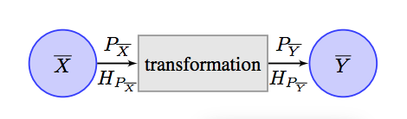

Fig. 1. Transformation block implementing $Y=f(X)$. *X* is the data source and *Y* the transformed data.

Then, $\overline{X}$ carries a prior information and $\overline{Y}=f(\overline{X})$ is derived from it, as shown in figure (), where $\overline{X}$ represents the data source (real data) and $\overline{Y}$ represents the transformed data $\overline{Y}=f(\overline{X})$. In this scenario, the point of interest is in whether all of the relevant information extant in $\overline{X}$ is transferred to $\overline{Y}$.

For this particular task, the *entropy balance equations* defined will be used for evaluating the effectiveness of a transformation by using well-known measures dating back to Shannon. In the following sections, the definition of the balance equations with the measures used to calculated it will be presented. Once the scheme has been schedule, the information theoretic tools mentioned in the papers [] gives us a series of information-theoretic concepts that are going to be essential for conceptualizing and visualizing both the transmission of information in the channel and the evaluation of an information source.

#### Measurements: Confusion Matrix

From [] consider a set of $k$ true classes $\{x_{1},x_{2},…, x_{k}\}$ and a discrete random variable $X$ following a prior class distribution $P_{x}$, and a set of $N$ instance patterns each belonging to one of the true classes. Then a classification is a process where each of these instances are assigned to one of the predicted classes $\{y_{1},y_{2},…, y_{k}\}$ generating a discrete random variable $Y$ with a prior distribution $P_{y}$ [].

Thus, we can consider the joint event of a classification process consisting on the presentation of an instance of an input class $X= X_{i}$ and deciding a predicted output class $Y= Y_{j}$.

For the performance evaluation then, a *confusion matrix $C_{XY}$* is type of contingency table (explicar nota) that counts the occurrences of the joint events. This matrix tallies as mentioned before the true labels $x_{i}$ of the entries (inputs of a classifier), against the predicted ones $y_{i}$ (outputs of the classifiers) to check the predictors performance

Each element of the table $(i,j)$ is the number of instances in the test set which belonging to the class $x_{i}$ are classified as $y_{j}$. ( $i= j$ means a correct classification)

Then, the maximum likelihood estimate for the joint probability of every label-prediction pair is the element of the matrix at such index divided by the total number of instances of the test set

$$P_{XY}=\frac{C_{XY}}{N}$$

hence, we can estimate the joint probabilities and their marginals. Since the calculation of entropy only depends on the distributions of the variables, through the matrixes of confusion we will easily obtain the desired measurements.

[https://www.researchgate.net/publication/259743406_100_Classification_Accuracy_Considered_Harmful_The_Normalized_Information_Transfer_Factor_Explains_the_Accuracy_Paradox]

## Use cases

In general, For the performance analysis of the supervised classification tasks, we can notice that there is a lack of good visual evaluation methods

Se vea que la herramienta que se ha hecho sea útil

From the

The Receiver Operating Characteristic (ROC) curve [] has often been considered a good visual characterization for the binary classification, but it´s generalization to higher input and output set cardinals is not as effective. Likewise, an extensive Aurea Under the Curve (AUC) for a ROC, have been considered an indicator of good classifiers, but the calculation of its higer dimensional analogue, the Volume Under the Surface (VUS) () is less manageable. After reviewing the unavailability of tools used for the classification, then we will use the concepts presented

Lean que se usa el ROC para temas de clasificación en el caso binario [], but its generalization to higher input and output set cardinals is not as effective. Likewise, as mentioned in the introduction [] an extensive Area Under the Curve (AUC) for a ROC has often been considered an indication of good classifiers (), but the calculation of its higher dimensional analogue, the Volume Under the Surface, (VUS)

### Multiclass classification evaluation (CBET)

The *Channel Binary Entropy Triangle* is mainly used as an exploratory data analysis tool for visual assessment, helping to visualize the performance of supervised classifiers in a forthright way. We can figure out the scenario in which we have the contingency matrix of a classifier on a supervised classification task for the random variables of true class $K \sim P_{K}$ and the predicted labels $\hat{K} \sim P_{\hat{K}}$. These variables now will play the role as shown in the binary case of section () of the distributions $P_{X}$ and $P_{Y}$.

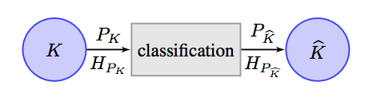

Figure ()

The contingency matrix can be perceived as the joint distribution $P_{K\hat{K}}$ between random variables. Therefore, using the balance equations defined and the consequent Entropy Triangle we can reach a more complete understating of how the classifier is performing.

From the representation of the *de Finetti* diagram the sides and vertices of the triangle depicts classifier performance-related qualities, as the following mentioned in []:

* The lower side represent the geometric region where $P_{X}$ and $P_{Y}$ are independent, meaning that there is no mutual information between the distributions, *so the closer the classifier is to this zone, the more unreliable the classifier decision are.*
* The left side represents the region where the marginals of $P_{XY}$ are uniform, which means that the classifiers are not trained with overrepresented classes and therefore cannot specialize in any of them. In other words, they operate on perfectly balance distributions, so *the closer to the left side, the more generic the classifier is.* (most difficult multiclass problem)
* Finally, the right side locus, represents the situation where the marginals are equals $P_{X}= P_{Y}$, meaning that there is not variation of information, hence perfect accuracy. This characterizes *classifiers which transfer as much information as they can*.



Reprinted ()

We can now move to the evaluation of the vertices of the triangle, which will represent the ideal, prototypical classifier []:

* The upper vertex represents *optimal classifiers* with the highest information transfer from input to output $F_{XY}=\left[0,1,0\right]$
* The left vertex exemplifies an *inaccurate classifier*, with low information-transfer $F_{XY}=\left[0,0,1\right]$
* The right vertex represents *underperforming classifiers*, with low information transfer $F_{XY}=\left[0,0,1\right]$

Once the main regions are defined, we are going to move to a real example in which we can actually see the performance of some real classifiers using in this case as a experiment the *Knn-classifier* and the *Naïve-Bayes classifier.*

Knn-Classifier

We are going to evaluate, based on the previous regions we defined, the performance of the *knn* classifiers, observing the variation of the information measures for the joint distributions $P_{K\hat{K}}$ while varying the number of neighbors, of both databases.

As we can see in the Figure (.a) the number of neighbors needed for the best classification performance of the Breast Cancer dataset is *k* = 5. In general, for this database, we can see that the classifier is performing in the region where the marginals of the joints distributions are almost uniform (balanced joint distributions) so they are general classifiers, and the mutual information between the variables is high, so the performance of the classifier is near to the optimum case.

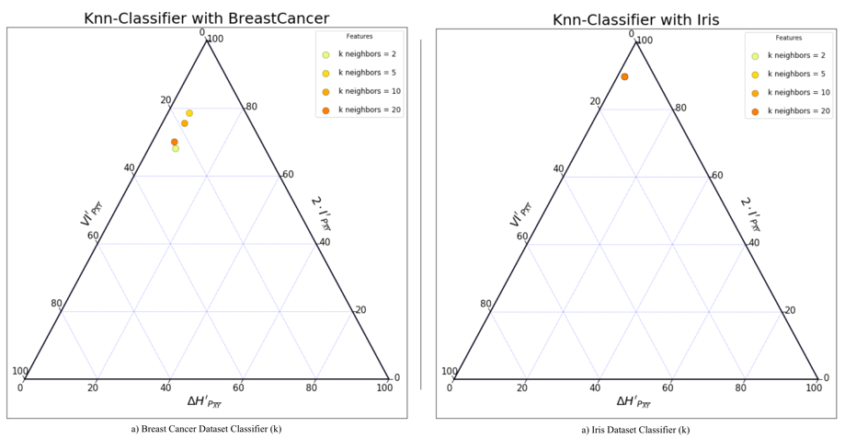

Figure ()

As soon as we increase the number of neighbors (*k* >5) the performance of the classifier decrease. In the Iris case (Figure (.b)) we can appreciate no variation when modifying the number of variables, and the performance is mostly optimum, near the region with the highest information transfer ($F_{XY}=\left[0,1,0\right]$)



Figure ()

Once evaluated the performance of the databases, we are going to check how the information varies depending on the size of the training set we use to model the classifier. First, in figure () we can appreciate with the Breast Cancer dataset that reducing the size of the training set worsens the classifier, as the mutual information shared by the $K$ and $\hat{K}$ variables is lower.



Figure ()

Figure () shows the same behavior with the Iris dataset, as when we decrease the amount of data used for the classifier modelling, the classification will be worse.

Naïve-Bayes Classifier

We will follow the same procedure as with the *Knn*, in the first scenario we are going to evaluate the performance of the Naïve-Bayes Classifier using the default train set size provided by *sklearn* () and then we will see how it performs decreasing the set size.

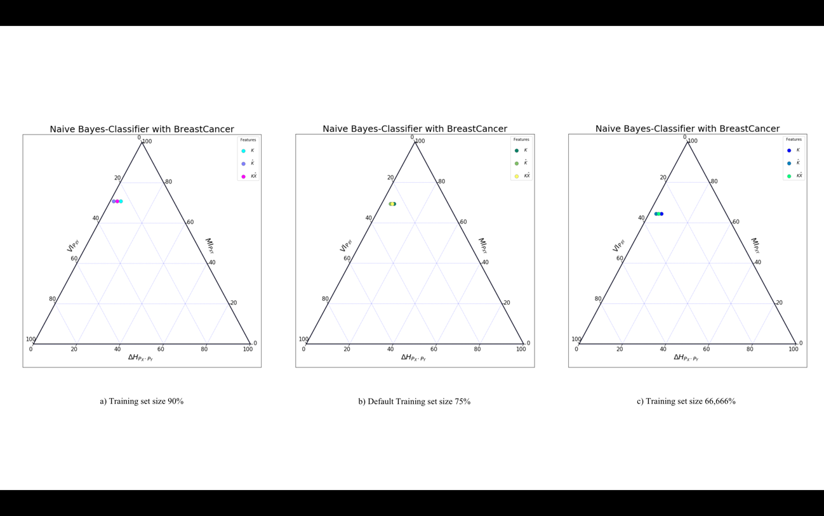

Figure ()

From figure () we can observe the slight decrease of the mutual information of the joint distributions with the decrease of the train set size, at the same time as the joint distribution of the variables shows a higher information variation. In Figure (.a) we can appreciate that the marginals of the joint distribution are mostly uniform, meaning that the classifier is mostly generic.

Compared with the figures of the *knn* scenario, we can see a similar performance while talking about information transmitted from the true classes random variable to the predicted one. However, we can appreciate that the classifier performing the best is the *knn* model with 5 neighbors.

### Source exploratory Data Source evaluator (SMET)

The Source Multivariate Entropy Triangle is a multivariate extension of the bivariate channel case, created for the representation for the entropic content of multivariate distributions where we can analyze, for instance, which features contribute the most to the total bound information in a classification dataset.

The figure [] extracted from [] presents the case gives a schematic representation of a machine learning task for the case of supervised multi-class classification. We can use the framework developed in this paper to analyze the information content of any of the virtual data sources represented by the dashed rectangles as instances of those systems presented in figure (). Specially we may study statistical multivariate sources K, the res

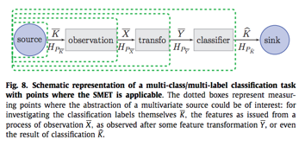

Figure ()

This tool can help us to analyze whether the data we are using in some supervised or unsupervised classification task is good enough for solving it. Then we can interpret some regions as in the previous case for characterizing the databases used in a machine learning task as mentioned in [].

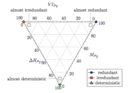

Figure ()

* ${∆H}_{P_{K}}$ quantifies how unbalance the class variable is. From [] we know that the greater this quantity is, the easier determining it with a possible encoding. In the other hand the lower the ${∆H}_{P_{K}}$, the easier $K$ is to determine from any feature.
* $M_{P_{K}}$ quantifies the information of $K$ provided by another variables $K^{C}$. The higher ${M'}_{P_{K}}$ the more quantity of information is captured by the features and the easier the classification should be
* $H_{P_{K|K^{C}}}$ is the remanent entropy in the class variable not capture by the features. The higher the more difficult the classification is.

The position in the triangle provides information as to the difficulty of the classification task, prior to any inference of a classifier.

Figure () shows the representation of the *source multivariate entropy triangle* of a series of databases for their characterization depending of their information measures. The datasets evaluated will be the presented in table ()

|  |  |  |  |
| --- | --- | --- | --- |
| Dataset Name | Instances |  | |Support(*K*)| |
| Arthritis | 84 | 3 | 3 |
| Iris | 150 | 4 | 3 |
| Breast Cancer | 699 | 9 | 2 |

Table ()

Figure () represents the plot the entropies for each of the classes of the table, and we can differentiate from their positions, some types of datasets that can be represented.

* From the Arthritis dataset in figure (.a) one dataset that it´s almost balance with a lot of irredundant information not captured by the features, as the remanent entropy is relatively high compare with the others presented in figure ().
* Then from the Iris dataset, in figure (.b) we can see a balanced datasets ( ${∆H}_{P_{K}}≤$ 20%) with almost no redundant information, meaning that it is a good database from a classification task.
* The Breastcancer dataset in figure (.c) represent a dataset with no redundant information. ( $H_{P_{K|K^{C}}}≤$ 10%)



Figure ()

### Analysis of data transformation (CMET)

Aggregate Channel Multivariate Entropy Triangle CMET is an exploratory tool to assess the efficiency of multivariate channels. We also present a practical contribution in the application of these balance equations and diagrams to the assessment of information transfer efficiency for PCA as feature transformation and selection procedures in machine learning applications.



Figure ()

Data Transformation is used in machine learning the transform of available data for instance, observations in a dataset X, into another data with better characteristics, which will be represented as the transformed feature vector Y []. In a classification scenario as presented in figure [], we will need to explore different transformations of the observations for a better posterior classification. In our case, we will just evaluate the PCA feature transformation algorithm, (that is a a staple technique in statistical data analysis and machine learning based in the Singular Value Decomposition of the data matrix to obtain projections along the singular vectors that account for its variance in decreasing [].)

DUDAS CON LA REPRESENTACIÓN (logarithmic representation de iris??)

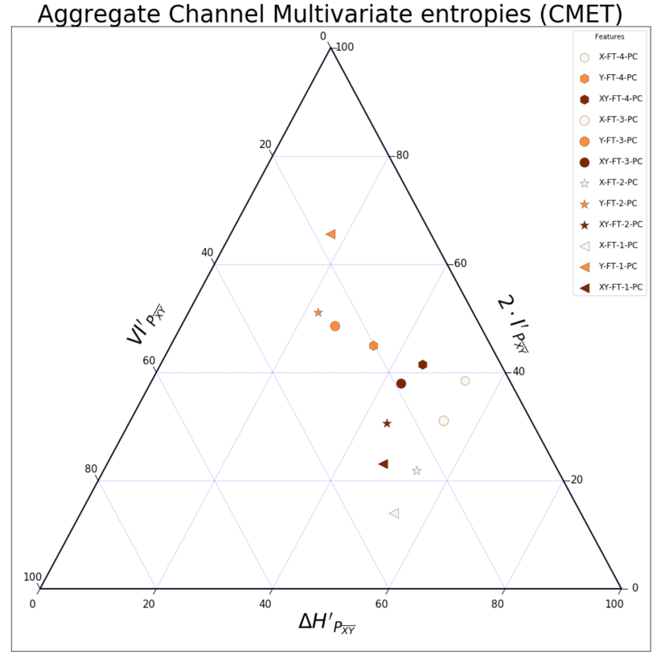

(Sacar comparativa del Data Transoframtion)

## Related work

There are developed a set of packages implementing the concepts seen from [] but developed for other programming languages. First, there is a Matlab package (nota a pie de página) created for the implementation of the *bivariate channel Entropy Triangle*, and other entropic measures that out of the scope of this Project such as the entropy-modulated accuracy (EMA) or the normalized information transfer function (NIT) presented in []. This software was just a proof-of-concept, but we can extract interesting insights for the code development of the *bivariate channel entropy triangle* even though Python and Matlab are two different languages.

In addition, we can find also a Weka plug-in created by [] intended to expand the information theoretic tools developed in the previous Matlab package, to a wider community for its use. Nevertheless, the functionalities represented fall short as it is just an extension of the previous package to the Weka community.

Furthermore, the Matlab package was a starting point for [] in the definition of the R package (nota a pie) for the extension of the *bivariate Entropy triangle*, for representing all possible cases shown in the theory [] extending the functionalities of the previous packages to a new level in which we can represent as well, the Source Multivariate Entropy Triangle (SMET) and the Channel Multivariate Entropy Triangle (CMET) thanks to the development of the balance equations for each case.

However, the philosophy of R caters the researchers but not the occasional user, for this reason we will implement the Python package for the aim of making the technique known to a wider audience and to lower the technological barrier for using it.

## Objectives

The main goal of this project is to develop the information theoretic evaluation metrics described by () presented in the section () in a full python package, distributable to the community. For this reason, we will define 2 groups of objectives that must be achieved for a satisfactory project compliance.

Functional requirements Objectives

1. The package must endow python with the information-theoretic measures described in []
   1. Information Theoretic measures for the bivariate case
   2. Information Theoretic measures for the multivariate source case
   3. Information Theoretic measures for the multivariate joint case
2. The package must endow python with the Entropy Triangles
   1. Entropy triangle for the channel bivariate balance equations case
   2. Entropy triangle for Source Multivariate case
   3. Entropy triangle for the Channel Multivariate balance equations case

Quality requirements:

1. The package must be distributable for the community
2. The code should be uploaded to a server for open source software.
3. We should develop an informal web site to introduce the package features and options.

Provide a User guide

# SOFTWARE IMPLEMENTATION

## System Architecture

In this section, we give a brief description of the requisites and features used for the definition the Python´s entropy triangle package as well as the package management system used for the development of the code, and the requirements needed to make the package distributable to the community.

As mentioned, Python is an open-source, portable, object-oriented software which is an interpreted programming language, meaning that there is no separation between compilation and execution. Usually when a program is written in a *compiled language* like C, then it is translated from the source language to a binary code (language understand by the computer) using the compiler and then this binary file is executed. But when using an *interpreted language* as Python there is not separation of the execution and compiling steps. Python converts the source code into an intermediate form called *bytecodes* and then translates this into the native language of your specific computer for the posterior running of the code. Then, Python takes advantage of the platform Independence (portability).

Moreover, at the starting point, we must understand the structure followed by Python when a program is developed. A program can be defined in this case as a group of structured modules (Python files) that are contained within a package. Each program module defines a series of functionalities that can depend or not of the other modules.

So, the Python packaging system was intended to follow the Linux-based systems, treating software as a collection of small self-contained units. Then the libraries then are bundled into packages, that might depend on other ones. These dependencies are usually fetched from a central repository that contains a big set of packages. [ref?]

The central repository will be in this case the *Python Package Index (PyPi)* which is the third-party software repository for Python. There you can find any package uploaded by the community for its use, so our objective will be to first define the whole package, and then adapt it in order to be distributed to the community.

### Python version used

When starting a Python project, the first step needed is to decide the version we want to use. There are 2 main versions for the package programming, in which the main difference between them are small disparities on the syntax. The release of version 3.x meant a total rewriting of all the programs developed in the previous version 2.x. Although the versions are still being updated, the code created will be implemented using the most updated: Python 3.6.5 (June 18).

### Python Packaging System

Python allows users to separate programs into modules that can be reused for other tasks.

A *module* is a single python file which can have a set of functions, classes or variables defined and implemented, whereas a *package* is a namespace which can contain a collection of modules or more packages in directories that give a package hierarchy.

Comentar archivo __init__

The __init__.py files are required to make Python treat the directories as containing packages; this is done to prevent directories with a common name, such as string, from unintentionally hiding valid modules that occur later on the module search path. In the simplest case, __init__.py can just be an empty file, but it can also execute initialization code for the package or set the __all__ variable, described later. [https://docs.python.org/3/tutorial/modules.html#packages]

Comentar paquete y además la distribución de paquetes

Open Source packages used

En la elaboración del paquete, se han utilizado una serie de paquetes usados ampliamente por la comunidad que nos aportarán funcionalidades necesarias para….

* Pandas is
* Numpy
* Matplotlib
* Sys warnings operator sicpy sklearn functools reduce random
* Ternary

### Python Package Manager

Python is an interpreted language, which can save you a lot of time during development because it does not need you to compile or link. The interpreter can be used interactively, which makes it easier to experience with language features, write disposable programs, or test functions when done bottom-up program development.

Both Python´s interpreter and extensive standard library are freely available in binary form and are available in source code for all major platforms. Nevertheless, while creating the package, the Anaconda distribution will be used for code development, as it will simplify the need of installing and uploading each library independently.

Anaconda is a free and open source distribution of the Python and R programming languages for data science and machine learning related applications that aims to simply the package management and deployment. The packages are managed by the package management system conda [https://conda.io/docs/]. The Anaconda distribution [https://www.anaconda.com/what-is-anaconda/] provides users a huge set of data packages, as well as the conda package and the virtual environment manager called Anaconda Navigator.

The Anaconda Navigator is a desktop graphical user interface (GUI) that allows to launch applications and easily manage conda packages, environments and channels without using command-line commands. [https://docs.anaconda.com/anaconda/navigator/]

### Python Package Index (Pypi)

https://pypi.org/pypi?%3Aaction=list_classifiers

## System Design

### Package Structure

### Auxiliar Module

### Evaluation Metrics Modules

### Plotting Packages

## Resultados

## Como se usa

#### Manual de uso

#### Manual de instalación

## Python Programming Language

Python is a powerful, object-oriented open-source scripting language created by Guido van Rossum in the earliest 90s. It has become one of the most used in the world because of characteristics like clean syntax, having an active community or being an open-source platform. In fact, it´s the 4th most used programming language during 2017 and 2018 as mentioned in [https://fossbytes.com/most-popular-programming-languages/].

However, why users are mostly using Python, is because of the ability of writing a library package to extend the functionality, or create a new one, and sharing it among the community. Besides, it was established as one of the most popular programming languages for scientific computing, and in special, for Data Science. Therefore, this is one of the main reasons for the entropy triangle development in Python, the elevated Data Science community and the high potential use of the package.

Comentar que se puede operar en muchos sistemas operativos distintos por lo que su diffusion será mayor

Python offers a great varieties of language versions that can be splitted in 2 groups, one for the 2.x and the other the 3.x. The groups differences are mainly the syntax used in every case, so for that reason the used version for the analysis and the code development is the most updated one of the series 3.x: Python 3.6.5.

Interprete

#### Python Interpreter and Anacondas

Python is an interpreted language, which can save you a lot of time during development because it does not need you to compile or link. The interpreter can be used interactively, which makes it easier to experience with language features, write disposable programs, or test functions when done bottom-up program development.

Both Python´s interpreter and extensive standard library are freely available in binary form and are available in source code for all major platforms. Nevertheless, while creating the package, Anacondas distribution will be used for code development, as it will simplify the need of installing and uploading each library independently.

Anaconda is a free and open source distribution of the Python and R programming languages for data science and machine learning related applications that aims to simply the package management and deployment. The packages are managed by the package management system conda [https://conda.io/docs/]. The Anaconda distribution [https://www.anaconda.com/what-is-anaconda/] provides users a huge set of data packages, as well as the conda package and the virtual environment manager called Anaconda Navigator.

The Anaconda navigator is a desktop graphical user interface (GUI) that allows to launch applications and easily manage conda packages, environments and channels without using command-line commands. [https://docs.anaconda.com/anaconda/navigator/]

The technical documentation of Weka is really helpful. The Weka API [25] is well explained and selfcontained. The Weka Wiki [28] illustrates the package creation process and provides templates for the common files. And the active mailing-list gives support for unexpected issues. Not to mention that Weka is open source, and the code availability is always a good help to understand the software in the process of interfacing it

The Weka features listed above, are the main facts that motivated our choice of Weka as the platform to implement the tools of our interest. Especially, the plug-in scheme through installable packages is essential to encourage Weka users to try new tools.

The program is implemented in Java, so the Java object-oriented architecture is a convenient environment to develop our tool packages. In addition, since we have to implement a visualization tool, the Java built-in graphic libraries are of great help. For example, making the graph elements interactive.

# DISCUSSION AND CONCLUSIONS

## Conclusiones

## Lineas Futuras

# APPENDICES

Ternary diagram

# References

Como has decidido hacer el document en Word no te puedo ayudar mucho con el formateo: use the charm in

<https://superuser.com/questions/625333/creating-references-that-are-bracketed-numbers-not-citation>

to build numbered reference lists and numbered brackets (IEEE format for references is the best, we engineers are all used to reading it).

# Comentarios

* Review your English, specially in the highlighted senteces/words.
* Use the paragraph formats of Word consistenly, otherwise the indexing tools will not work.
* Start working on the Reference section above by importing and properly numbering the refs.
* Go on inputting material: needs much more for me to be able to gauge the quality of the work.